CS1428 Lab 00h

# Name: Section:

Write your name at the top of this sheet. Answer the following questions and turn in this sheet before the end of class. You may use your instructor’s web materials, your book or an internet resource to answer these questions. (85 points) (Not for grade)

1. (10 pts) What environment do we use to develop and compile our C++ programs? What is the name of the compiler our environment uses?
2. (25 pts) Using the Eclipse write a very simple program. It must output your name, today’s date, and your lecture/section number. Name the source file **lab00h.cpp. (**Make sure to include the standard header as discussed in class**)** Compile and run it. Print and attach the source code to this work sheet. Upload the source to the homework upload.
3. (10 pts) What is an algorithm?
4. (10 pts) What is Computer Science?
5. (10 pts) What are some expressions? Make up 6 different, valid, C++ expressions.
6. (10 pts) What are the steps to start writing a program in Eclipse? What important thing must you always verify is selected? What does the error “Binary Not Found” mean?
7. (10 pts) What is the difference between assembly and machine code?
8. (15 pts) Label the picture. (5 items)

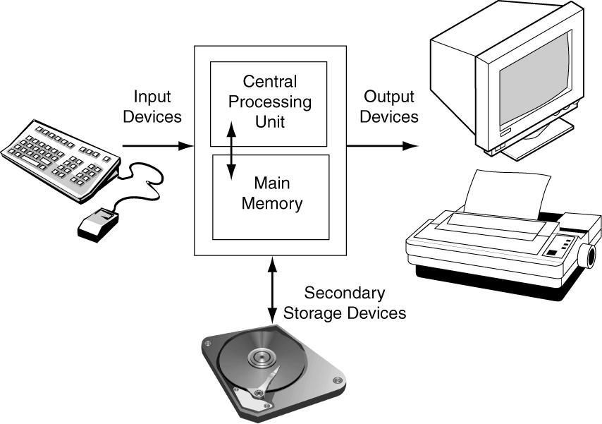

**Note:** Print and attach a copy of **lab00h.cpp** to this worksheet along with the output as well. **UPLOAD** all source files and program output to my homework folder:

To access my homework folder, Go to <http://cs.txstate.edu/~masone> and click on the link for your lab section. Login with your Texas State user ID and password, browse for the file, and then click on submit. You will also turn in a hard copy stapled to the back of this lab assignment.